**MAC Address:**

A MAC address, which stands for Media Access Control Address, is a physical address that works at the Data Link Layer. In this article, we will discuss addressing a DLL, which is the MAC Address.

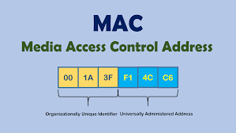

**ARP:-**

ARP stands for Address Resolution Protocol. It is a protocol used in computer networks to translate IP addresses to physical MAC addresses. When a device wants to communicate with another device on the same network, it needs to know the MAC address of the target device. ARP resolves this by broadcasting a request to all devices on the network asking for the MAC address associated with a specific IP address. The device with the corresponding IP address responds with its MAC address, allowing communication to proceed. ARP is essential for enabling communication between devices on the same network. ARP is very useful in networking-

**MAC Address Discovery:** It helps devices find the MAC addresses of others on the same network.

**Packet Forwarding:** ARP aids routers in forwarding packets between different networks by determining the MAC addresses of next hop routers.

**Dynamic Host Configuration:** Used in DHCP to assign IP addresses dynamically to devices on a network.

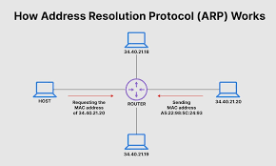

**RARP:-**

RARP, or Reverse Address Resolution Protocol, serves as a critical networking protocol aimed at mapping physical MAC addresses to IP addresses. Unlike its counterpart, ARP (Address Resolution Protocol), which resolves IP addresses to MAC addresses, RARP operates in reverse, fulfilling the need for IP address assignment based on MAC addresses.

The necessity for RARP arises in various networking contexts, particularly in legacy systems or specialized configurations. It proves indispensable in scenarios where devices require dynamic IP address allocation but lack the support or implementation of newer protocols like DHCP. Commonly, RARP finds application in environments featuring diskless workstations or embedded systems, where devices boot from a network and necessitate IP addresses dynamically during initialization.

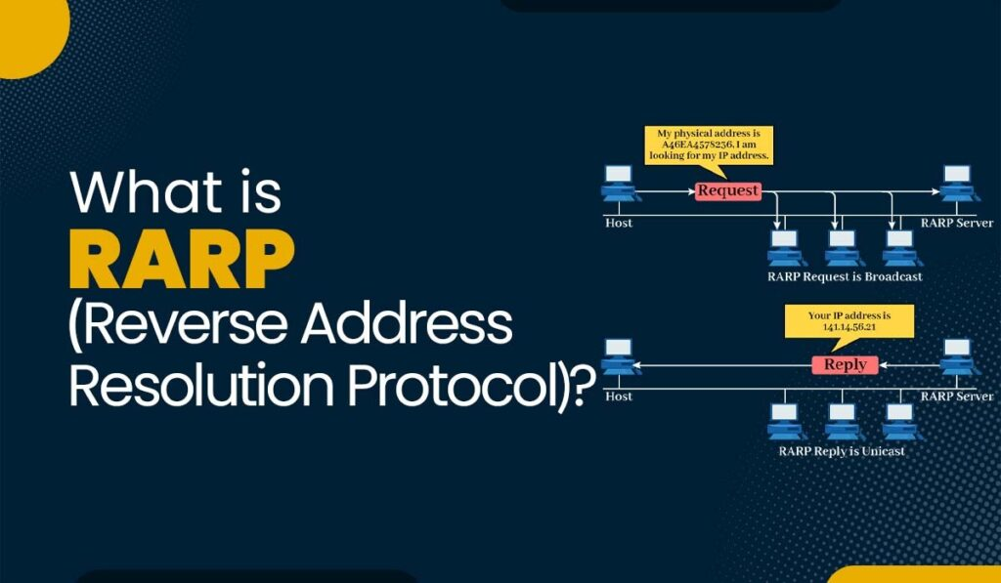

**Inverse Address Resolution Protocol (InARP) :-**

Inverse ARP (InARP) is a protocol used to discover the IP address of a device when only its MAC address is known. It operates in the reverse direction compared to ARP, resolving MAC addresses to IP addresses. InARP is commonly used in Frame Relay and ATM networks for dynamic IP address assignment based on MAC addresses, simplifying network configuration.

The working of InARP involves devices exchanging InARP messages to map MAC addresses to IP addresses. When a device needs to discover its IP address, it sends an InARP request packet containing its MAC address. Other devices on the network, such as routers or switches, respond with InARP reply packets containing the corresponding IP address mapped to the MAC address.

**Proxy ARP:-**

Proxy ARP enables a router to respond to ARP requests on behalf of devices outside its local subnet. It allows devices on one network segment to communicate with devices on another segment without explicit routing configuration. When a device sends an ARP request, the router replies with its own MAC address, acting as a proxy. This relays traffic between the two segments seamlessly. Proxy ARP simplifies network setup and facilitates communication between devices on different network segments.

**Gratuitous ARP:-**

Gratuitous ARP is an ARP packet where the source and destination IP addresses are the same, used to update ARP tables in neighboring devices. It's typically sent by a device to announce its IP-to-MAC mapping, verifying and updating ARP caches across the network. This helps prevent potential IP address conflicts and ensures network efficiency and stability.

**ARP Spoofing:-**

ARP spoofing is a malicious technique where an attacker sends falsified Address Resolution Protocol (ARP) messages over a local area network. These spoofed ARP messages link the attacker's MAC address with the IP address of a legitimate device, diverting traffic intended for that device to the attacker's machine. This enables the attacker to intercept, modify, or eavesdrop on network communication between other devices, potentially leading to various security breaches such as man-in-the-middle attacks or data theft.

**(KARAN TOLAMBIYA)**

**25-05-2024**